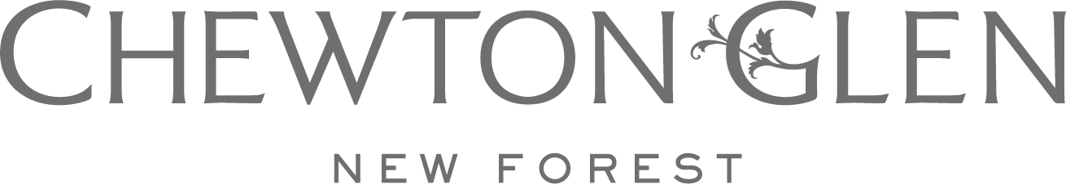

FOR IMMEDIATE RELEASE FEBRUARY 2024

NEW FOREST COUNTRY HOUSE HOTEL & SPA CHEWTON GLEN LAUNCHES THE UK’S FIRST SPA PARTNERSHIP WITH HEALTHY HAIR TRAILBLAZERS, MONPURE

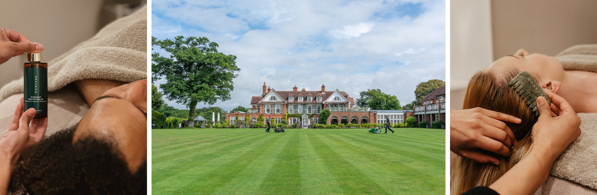

London (February 2024) | Starting this month, quintessential English country house hotel and spa Chewton Glen is delighted to be partnering with pioneers of healthy hair, Monpure. A tranquil oasis on the edge of the New Forest, Chewton Glen will now offer a range of results driven Monpure treatments to guests at its award-winning spa, becoming the first spa in the UK to offer bespoke treatments using the brand’s signature hair and scalp health products.

Treatments will be available to both in-house hotel guests and non-residents, with two results-driven experiences to choose from:
- Signature Follicle Boost Treatment: Ideal for all hair types, this treatment is aimed at those experiencing hair thinning and hair loss, or wishing for thicker, fuller hair. Guests will enjoy a stimulating scalp massage that nourishes the hair follicles with nutrient-rich vitamins, and promotes improved cell turnover on the scalp, using Monpure’s award-winning and efficacious range of products. From £145
- Bespoke Scalp Detox or Nourish: Starting with a comprehensive consultation with one of Chewton Glen’s expert therapists, this bespoke treatment is tailored to meet guests’ specific hair needs, considering factors such as stress, ageing, menopause or hormonal changes, which can all impact scalp and hair health. From £165

Multi-award-winning scalp and hair health brand Monpure has developed innovative formulas and breakthrough treatments that cultivate hair wellness from follicle to tip, empowering individuals to regain inner confidence while fostering strong, healthy hair. The brand is the first to utilise highly concentrated active ingredients, such as retinol, lactic acid and salicylic acid, in hair care formulas, which work to accelerate cell turnover on the scalp and improve the dermatological condition. Established with the steadfast ambition to push boundaries in the hair wellness space ever forward, Monpure brings forth novel techniques and trailblazing treatments with a collective of experts, scientists, trichologists and dermatologists at the helm, working to find real solutions to hair loss, hair thinning and scalp irritation.

Kerry Hudson, Spa Director for Iconic Luxury Hotels says “We are so thrilled to be working with Monpure to offer innovative and results-driven hair and scalp solutions to our guests. We believe personal wellbeing goes far beyond the spa and are delighted to be offering Monpure’s inclusive and empowering treatments, not only building healthier hair but inner confidence too.”

“Monpure is delighted to announce our partnership with the esteemed Chewton Glen”, says Nate Bigger, CEO of Monpure. “This collaboration marks a significant milestone in the realm of luxury spa experiences. We are thrilled to introduce Monpure’s pioneering scalp and hair health solutions and treatments to this renowned wellness retreat. At Monpure, we are committed to innovating and transforming hair health. The serene ambiance and exceptional care provided by Chewton Glen align perfectly with our goal to foster confidence and empower individuals through dedicated scalp and hair wellness. This partnership is not just a union of two entities, but a convergence of luxury, health, and well-being.”
A haven of wellbeing, Chewton Glen is one of the UK’s most loved country house hotels and spas: a true English original. Guests can stay in one of the charming Main House bedrooms, or for the ultimate countryside experience, opt for one of Chewton Glen’s Treehouse Suites, tucked away amongst the lush forest. The award-winning Chewton Glen Spa offers both in-house hotel guests and Spa Members a range of bespoke body and facial treatments, a hydrotherapy pool, thermal facilities, and heated indoor and outdoor swimming pools, while outside, nature trails through the enchanting New Forest await.

@chewtonglen | www.chewtonglen.com

Press Contact:
J/PR Iconic Luxury Hotels
Francesca Moore Angela Day
iconic@jpublicrelations.com angela@iconicluxuryhotels.com

-ENDS-

About Chewton Glen

Chewton Glen is a five-red star privately-owned luxury country house hotel, located on the edge of the ancient New Forest National Park in Hampshire and just a few minutes’ walk from the sea. A member of Relais & Châteaux, this family-friendly resort features an award-winning restaurant, world-class spa and leisure activities, luxurious accommodation and modern meeting facilities and a Childrens Club. The hotel has 72 individually designed bedrooms and suites including 14 tree-house suites, a nine-hole par three golf course, croquet lawn, indoor and outdoor tennis courts, a spa which has been voted the best in Europe and a purpose-built cookery school, bakery and informal restaurant opened in association with James Martin.

About Iconic Luxury Hotels

Iconic Luxury Hotels was founded in December 2016 and is part of L+R Hotels (landrhotels.com) - a highly motivated family-owned global hotel investment and management company - who have an extensive portfolio of over 105 hotels, with approximately 21,000 bedrooms. Iconic Luxury Hotels is an expanding collection with an international focus. The collection is comprised of an eclectic array of properties each of which celebrates distinct architecture, cultural heritage, and natural surroundings.

Each property has its own character, traditions, and stories but they share a common commitment to delivering outstanding experiences. The current portfolio includes some of the world’s most famous hotels from Cliveden House, one of England’s finest country estates, to the Hotel Excelsior in Italy which is the home of the Venice International Film Festival. The other UK hotels are comprised of Chewton Glen, an English estate on the South Coast; The Lygon Arms, a 14th Century Coaching Inn in the Cotswolds; 11 Cadogan Gardens in Chelsea, one of London’s most prestigious residential neighbourhoods; The Mayfair Townhouse which sits in the heart of the exclusive Mayfair district; and the newest addition to the group, The Chelsea Townhouse which opened its doors in September 2023 just over the road from 11 Cadogan Gardens.

About Monpure
Monpure London is an award-winning scalp and hair health brand, designed to alleviate scalp discomfort and irritation, prevent hair thinning and promote stronger, healthier hair.

Monpure’s scientifically proven formulas help create the optimum environment for hair to grow by rebalancing the scalp, clearing blocked follicles, and strengthening and rebuilding strands at the root. The brand is the first to utilise highly concentrated active ingredients, such as retinol, lactic acid and salicylic acid in hair care formulas, which work to accelerate cell turnover on the scalp and improve its dermatological condition. This nourishes the scalp and hair at their core, transforming it into a source of empowerment so hair can grow strong and healthy.Products are dermatologically tested, suitable to use during pregnancy and breastfeeding and cruelty-free.

