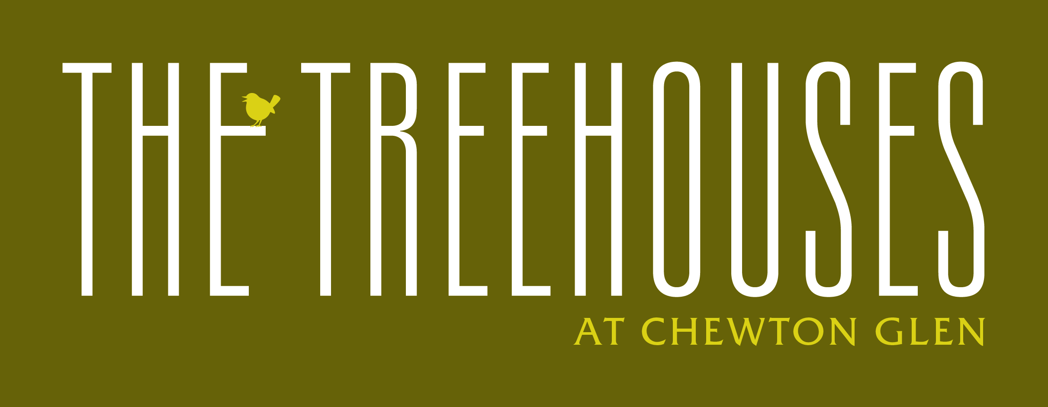
WELCOMING DOGS
We are delighted to welcome dogs to our Treehouse suites at Chewton Glen. To ensure a relaxing and enjoyable experience for all our guests, both two-legged and four-legged, we kindly ask you to observe the following guidelines:
Dog Eligibility: Dogs should be at least 1 year old, weigh no more than 30 kilos, and be vaccinated against Rabies.
Where Your Dog Can Go: Dogs are welcome throughout the grounds, in the main Hotel Lobby, Lounges, and on the Terraces. For the comfort of all guests, they are not permitted in the Dining Room, Spa, Outdoor pool, Kitchen Restaurant, Croquet lawn, Golf course, Driving range, or Tennis courts.
Leash Policy: Dogs must be kept on a lead when in public areas or within the grounds.
Comfort: Dog beds are available upon request. Please note, dogs are not permitted on furniture in the lounges or terraces.
Leaving Your Dog: If you need to leave your dog alone in the room, kindly hang the provided fabric bone outside the door to inform our housekeeping team. Please be aware that we will not service the room while your dog is inside.
Cleanliness and Responsibility: Guests are responsible for cleaning up after their dogs in the grounds and woodlands. Waste disposal bins are conveniently located around the property.
Damage and Deep Cleaning: You are liable for any damage caused by your dog and may be charged for repairs or deep cleaning if necessary. An additional night's stay may be applied if deep cleaning is required.
Additional Charge: A fee of £35.00 per dog per day will be added to your bill. This includes treats, a comfortable dog bed and a bowl.
To help us provide a warm, personalised welcome, please share your dog’s name and breed when booking.
We look forward to making your dog’s stay truly memorable!

Dog (s) name _________________________ Breed _____________________
Please sign and return a copy of this form to reservations.
Guest Signature ______________________ Date _____________________

I, the undersigned, declare that I have read and agree to be bound by the Regulations for staying with my pet at Chewton Glen Hotel.

